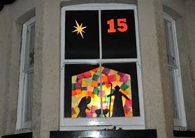Advent Windows

Here is a complete list of where and when to find the Advent Windows.

A new window will ‘appear’ each day and will tell a different part of the Nativity story.

Most of the windows will be lit up at night, however sometimes this may not be possible, and it may be more visible in the day. A photo of each window will also be posted on our school website each day. Please also note that the school windows may not be visible from the road but will be available on the website.

1st Dec: 3 The Rookery, Main Street, Barnstone, NG13 9JP

2nd Dec: 10 Main Street, Langar, NG13 9HE

3rd Dec: Chestnut Farm House, Main Street, Langar, NG13 9HE

4th Dec: 25 Butler’s Field, Langar, NG13 9HS

5th Dec: 19 Belvoir Crescent, Langar, NG13 9HU

6th Dec: 3 Park Road, Barnstone, NG13 9JF

7th Dec: 10 Earl Howe Crescent, Langar, NG13 9HF

8th Dec: Gwenlyn, Works Lane, Barnstone, NG13 9JJ

9th Dec: Four Points, Mill Lane, Aslockton, NG13 9AS

10th Dec: 67 Park Road, Barnstone, NG13 9JF

11th Dec: Byre House, Church Lane, Langar, NG13 9HG

12th Dec: Churchgate Cottage, Churchgate, Colstone Bassett, NG12 3FP

13th Dec: 3 Church Lane, Langar, NG13 9HG

14th Dec: Blue Lias, Cropwell Road, Langar

15th Dec: Nutcroft, Main Street, Langar, NG13 9HE

16th Dec: Earl Howe Crescent, Langar, NG13 9HF

17th Dec: Langar Primary School

18th Dec:

19th Dec:

20th Dec:

21st Dec:

22nd Dec:

23rd Dec:

24th Dec: