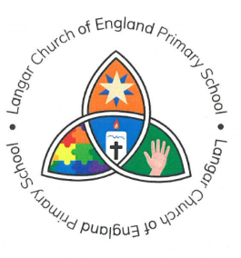

Langar C of E Primary School Head Teacher:
Barnstone Road Mr Walker-Jones
Langar
Nottingham 23rd July 2024

NG13 9HH

01949 860056

Dear Parents/Carers,

Year 3 and 4 Trip

We are delighted to inform you of a curriculum trip to The Jorvik Viking Centre in York.

Place/places being visited | Jorvic Viking Centre and DIG Tour - York
Date | 3rd October 2024
Time of departure | We will be travelling to York by train. We are asking parents to drop their child at Newark Northgate to catch the 8.32am train which arrives in York at 9.29am. Please ensure that you child is dropped off no later than 8.15am.
Time of arrival back at school | We will return from York on the 3.33pm train and arrive back at Newark Northgate at 16.18pm for picking up by parents.
Dress Code | School Uniform, sensible shoes for walking in and a rainproof.
Lunch Arrangements | Children will need a packed lunch for the day which must be brought in a back pack.
Any additional information (spending money etc) | No spending money is required.
Cost | The total for the trip is £29.45. Please ensure that the trip total is paid by 20th September 2024.

If you are a low-income family and your child is in receipt of free school meals, please come and see Mr Walker-Jones as you may be able to access financial support towards the cost of the trip.

Yours sincerely

Mrs Nicholson
Class Teacher

