Curriculum Area |  | Autumn 1 | Autumn 2 | Spring 1 |  | Spring 2 | Summer 1 |  | Summer 2
 | The Big Question! | Who am I? | How do we celebrate? | Is there anything above the clouds? |  | Who is Afraid of the Big Bad Wolf? | Are Minibeasts like me? |  |  | Where would I bury my treasure?
 | Themes | All about me  Superheroes  People who help us | Seasonal Change - Autumn  Christmas  Bonfire Night | Light and Dark  Space  Transport and Travel |  | Traditional Tales | Minibeasts  Growing and Changing  Farming |  |  | Treasure Island
 | English  (Read to Write Foundations) | The Something  (A Friendship and Animal Theme) | Juniper Jupiter (A Superhero Theme) | Star in a Jar  (A Star Theme) |  | Little Red  (A Traditional Tale Theme) | The Extraordinary Gardener  (A Plant Growing Theme) |  |  | The Storm Whale  (A Seaside Theme)
 | Maths  (WRM) | Getting to know you (Take this time to play and get to know the children!) | Just like me!  It's me 1, 2, 3!  Light and Dark | Alive in 5!  Growing 6, 7, 8 |  | Building 9 and 10  Consolidation | On the move  Superhero to 20 and beyond |  |  | First, then, now  Find my pattern
 | PSED (Jigsaw) | Being Me in My World | Celebrating Difference | Dreams and Goals |  | Healthy Me | Relationships | Changing Me
 | The Natural World | Properties of materials and their uses  Describe the local environment, using all their senses to explore the natural and urban world | Autumn - seasonal changes | Melting/freezing  Looking at natural and man made materials and cause and effect |  | Spring - How things grow and change | Make observations of plants and animals  Explore the natural world around them and make observations and draw pictures  Understand some of the processes in the natural world- life cycles |  |  | Compare the local environment and the seaside  Describe other environments
 |  | Where we live- local landmarks |  |  |  |  |  |  |  | Use and understand simple maps
 | Past and Present | Who is in your family?  Our History – How we have grown and changed.  Discussion of families - similarities and differences  Make maps of local area  People Who Help us.  Rosh Hashanah, Yom Kippur, Sukkot, All Saints Day | Bonfire Night – Guy Fawkes  Christmas in the past  How Christmas is different around the world  Christmas- changes linked to toys  Know some similarities and differences between religious and cultural communities- look at different celebrations e.g. Christmas, Bonfire Night, Diwali, etc. | Now and then transport  Space Travel- Moon Landings linked to  Neil Armstrong  Look at Helen Sharman- astronaut  Use as a way of developing understanding of significant events in the past.  Getting around- using cars, planes, boats, rockets- cultural differences |  |  |  |  |  | Now and then seaside  Look at life in the past e.g. grandparents holidays- photos, books, etc.
 | People, Cultures and Communities  RE |  | Autumn, Diwali, Hannukah, Christmas |  | Chinese New Year, Epiphany, Ash Wednesday, Shrove Tuesday, St David’s Day, | Holi, Palm Sunday, Passover, Eater, Start of Ramadan, Mother’s Day | Eid (May) |  |  | Looking after the environment  Summer Solstice, Father’s Day
 |  | UC God  Why is the word God so important to Christians? | UC Incarnation  Why do Christians perform nativity plays at Easter?  Diwali | Special Objects  (Christianity, Judaism, Hinduism, Islam)  Chinese New Year |  | UC Salvation  Why do Christians put a cross in an Easter Garden?  *Trip to church | Animal Stories  (Judaism, Buddhism, Sikhism, Islam) |  |  | Our wonderful World  (Judaism, Hinduism, Islam)
 | Being Imaginative and Expressive (Music) Charanga | Me! | Little Angel Gets her Wings | Everyone |  | Our World | Big Bear Funk |  |  | Reflect, Rewind and Replay
 | Being Imaginative and Expressive  (Art) | Colour exploring and mixing | Drawing with accuracy  Selecting tools for a purpose  3D structures | Exploring the use of textures |  | Colour mixing with intent | Joining materials together |  |  | Sculptures - Junk model boats / pirate ships
 | Creating With Materials (D&T) |  |  | Cooking and Nutrition |  | Weaving | Structures/ materials - building
 | Technology  (Purple Mash) | Topic Pins - UW, PCC All About Me, My Feelings, Growing - programme navigation, discussion | Celebrations - paint projects - UW, PCC | Mashcams - CL Mashcams allow children to role play a wide variety of different roles and characters, with space to input their picture and write or record their voice.  2Desgin and Make - EAD - create and explore 3D models |  | To Create a story - CL provides an opportunity for story writing through the use of multimedia tools. The children can add clip art and their own images, their own voice recording and their own musical sounds, as well as adding movement to their picture and finally playing their pages like a book and listening to all the sounds added | Using an ipad to take photographs of minibeasts. |  |  | Writing a postcard - keyboard typing skills - W
Physical
(Get Set 4 PE)

 | Values | Take Care | Thoughtfulness | Fairness |  | Love | Respect |  |  | Gratitude
 | Learning Skills | Independent Enquirers | Self Managers | Team Workers |  | Reflective Learners | Creative Thinkers |  |  | Working on all to achieve key skills.

 | Class 2 – Year A
 | Discovering the past and exploring the world, to create a better future
 | Autumn |  | Spring |  | Summer
Maths | Place Value, Addition and Subtraction, Shape |  | Money, Multiplication and Division, Length and Height, Mass, capacity and temperature |  | Fractions, Time, Statistics, Position and direction
English Text | 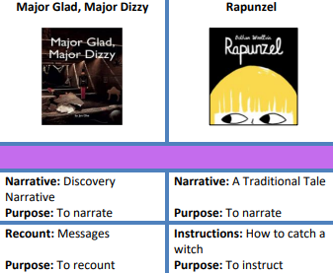 |  | 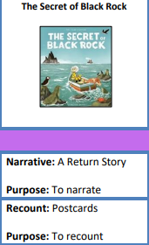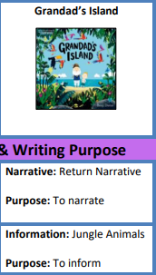 |  | 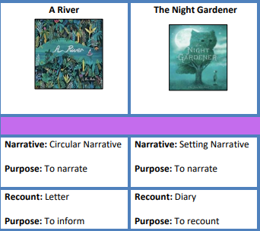
History | Childhood Then and Now  Have children always been treated fairly? |  | Intrepid Explorers  How can we show respect for other countries and cultures? |  | Travel and Transport  Does the transport we use allow us to take care of the environment?
Geography | Where do I Live? |  | Let’s Go to the Arctic |  | Map Makers
Science  Y2 Obj | Growing Plants  What are toys made from |  | Living in Habitats  Growth and survival |  | Exploring Everyday Materials  Super Scientists
DT | Puppets |  | Perfect Pizzas |  | Vehicles
Art | Mark Making |  | Colour Creations |  | Self Portrait
Music | Hey You!  Little Angel Gets her Wings |  | In the Groove  Zootime |  | Round and Round  Your Imagination
PE | Gymnastics  Team Building |  | Striking sand Fielding  Athletics |  | Dance  Gymnastics
PSHE | Being Me in My World  Celebrating Difference |  | Dreams  Goals and Healthy Me |  | Relationships  Changing Me
RE | UC God  What do Christians believe God is Like? | UC Incarnation  Why does Christmas matter to Christians? | Special Books  (Christianity, Judaism, Islam)  *Trip to church | UC Salvation  Digging deeper  Why does Easter matter to Christians? | Leaders and Teachers  (Christianity, Islam and Judaism) | UC Gospel  What is the good news that Jesus brings?
ICT | Online safety, Effective searching, Lego builders |  | Technology outside school, Grouping and sorting, Creating pictures |  | Spreadsheets, Coding
French | Colours and numbers |  | Ice Cream |  | Shapes

 | Class 2 – Year B
 | Discovering the past and exploring the world, to create a better future
 | Autumn |  | Spring |  | Summer
Maths | Place Value, Addition and Subtraction, Shape |  | Money, Multiplication and Division, Length and Height, Mass, capacity and temperature |  | Fractions, Time, Statistics, Position and direction
English Text | 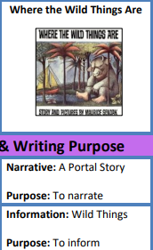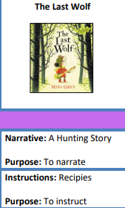 |  | 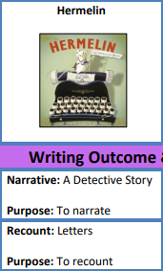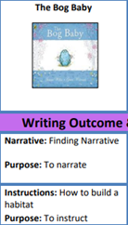 |  | 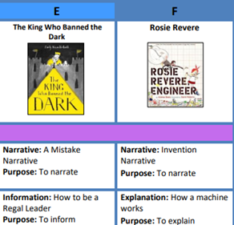
History | To Market, To Market  How can we take care of the traditions of the past?  Farming in the local area past and present  BBC - Nottingham Features - History of Goose Fair  LeftLion - The History of Nottingham's Goose Fair |  | Fire, Fire  Who should we thank for taking care of us?  The Great Fire of London  Medical breakthroughs:  Florence Nightingale and Mary Seacole, , Conrad Rontgen (X-Ray) 1895, Alexander Fleming 1928 (Penicillin) |  | - Communication then and Now  How can we show respect when communicating with others?  - William Caxton, Samuel Morse, Alexander Graham Bell and Tim Berners-Lee.
Geography | At the Farm |  | Around the World |  | Life in the City
Science  Y1 Obj | Identifying Plants  Identifying Animals |  | My Body |  | Everyday Materials  Seasonal changes
DT | Eat More Fruit and Vegetables |  | Moving Minibeasts |  | Stable Structures
Art | Earth Art |  | Henri Rousseau |  | Yayoai Kusama
Music | Rhythm in the Way We Walk  Magical Christmas Journey |  | Hands, Feet, Heart  Friendship Song |  | I Wanna Play in a Band  Reflect, Rewind and Replay
PE | Fundamentals  Invasion |  | Yoga  Target Games |  | Sending and Receiving  Net and Wall
PSHE | Being Me in My World  Celebrating Difference |  | Dreams  Goals and Healthy Me |  | Relationships  Changing Me
RE | UC God  Digging deeper  What do Christians believe God is Like? | UC Incarnation  Digging deeper  Why does Christmas matter to Christians? | What do Muslims Celebrate?  (Islam) | UC Salvation  Why does Easter matter to Christians? | UC Creation  Who made the world? | Special Places  (Christianity, Buddhism, Islam)  *Trip to church
ICT | Online safety, Maze explorer, Questioning |  | Online safety, animated story books, Making music |  | Spreadsheets, Pictograms, Presenting ideas
French | Greetings |  | Seasons |  | Little Red Riding Hood

 | Class 3 – Year A
 | Discovering the past and exploring the world, to create a better future
Maths | Autumn  Place value, Addition and subtraction, Area, Multiplication and division A |  | Spring  Multiplication B, Length and Perimeter, Fractions, Decimals A |  | Summer  Decimals B, Money, Time, Shape, Statistics, Position and Direction
English Text | 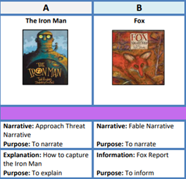 |  | 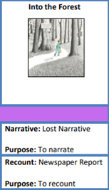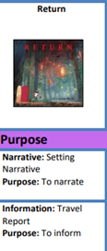 |  | 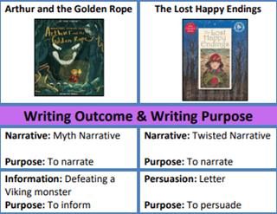
History | Why did the Anglo Saxons come to Britain?  Anglo Saxons, Picts and Scots |  | Robin Hood – man, myth or legend?  How can we take care to preserve the past? |  | How can we take care of children during times of war?  World War 2 - A local History study
Geography | Village Settlers |  | Our European Neighbours |  | Countries of the World
Science  Year 4 Obj | Living in Environments  Eating and Digestion |  | States of Matter  Changing Sound |  | Circuits and Conductors
DT | Seasonal Stockings |  | Seasonal Food |  | Light-Up Signs
Art | Recycled Art |  | Plant Art |  | William Morris
Music | The Dragon Song  Glockenspiel 1 |  | Three Little Birds  Let Your Spirit Fly |  | Bringing us Together  Reflect, Rewind and Replay
PE | Fundamentals and Team building/Fitness |  | Gymnastics, Ball Skills and Basketball |  | Dodgeball, Hockey, Athletics
PSHE | Being Me in My World  Celebrating Difference |  | Dreams  Goals and Healthy Me |  | Relationships  Changing Me
RE | UC Incarnation & God  What is the Trinity? | Identity and Belonging  (World View) | UC Creation & Fall  What do Christians learn from the creation story? | UC Salvation  Digging deeper  Why do Christians call the day Jesus dies, Good Friday? | Islamic Rites of Passage  (Islam) | UC People of God  What is it like to follow God?  *Trip to church
ICT | Coding, Online Safety, spreadsheets |  | Touch typing, Email, Branching databases |  | Simulations, Graphing
French | Phonics lesson 1- 2 I'm Learning French  Animals |  | I Can  Fruit |  | Presenting Myself  At the Café

 | Class 3 – Year B
 | Discovering the past and exploring the world, to create a better future
 | Autumn |  | Spring |  | Summer
Maths | Place value, Addition and subtraction, Area, Multiplication and division A |  | Multiplication B, Length and Perimeter, Fractions, Decimals A |  | Decimals B, Money, Time, Shape, Statistics, Position and Direction
English Text | 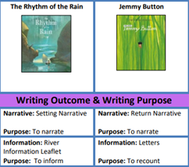 |  | 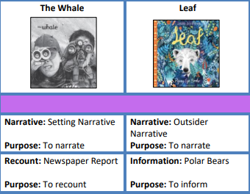 |  | 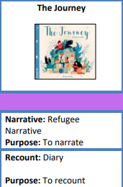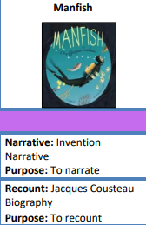
History | How did Britain change from the Stone Age to the Iron Age?  How can we take care, when discovering the past? |  | How different was the Mayan civilization c. AD 900 to life in Britain at that time?  How can respect be shown when we visit new countries? |  | Should we be grateful that the Romans came to Britain?
Geography | Earning a Living |  | The Rainforest |  | Volcanoes (Link to Pompeii)
Science  Year 3 Obj | Rocks, Fossils and Soils |  | How Plants Grow  Light and Shadow |  | Health and Movement  Forces and Magnets
DT | British Inventors |  | Making Mini Greenhouses |  | Story Books
Art | Sonia Delaunay |  | Seurat and Pointillism |  | Famous Buildings
Music | Mama Mia  Glockenspiel 2 |  | Stop!  Lean on Me |  | Blackbird  Reflect, Rewind and Replay
PE | Fundamentals, fitness and gymnastics |  | Yoga, Football, hockey |  | Cricket, Athletics, rounders
PSHE | Being Me in My World  Celebrating Difference |  | Dreams  Goals and Healthy Me |  | Relationships  Changing Me
RE | UC Incarnation & God  Digging deeper  What is the Trinity? | UC Gospel  What kind of world did Jesus want? | Special Foods  (Judaism, Islam) | UC Salvation  Why do Christians call the day Jesus dies, Good Friday? | Jewish Celebrations  (Judaism) | UC Kingdom of God  When Jesus left, what was the impact of Pentecost?
ICT | Coding, Online safety, spreadsheets |  | Writing for different audiences, Logo, Animations |  | Effective search, Hardware investigators
French | Phonics lesson 1-2 Musical Instruments  Vegetables |  | Ancient Britain  In Class |  | Goldilocks  Habitat

 | Class 4 – Year A
 | Discovering the past and exploring the world, to create a better future
 | Autumn |  | Spring |  | Summer
Maths | Place Value, Four Operations, Fractions |  | Fractions, Decimals, Percentages, Ratio, Units of Measure, |  | Area, perimeter and volume, Algebra, Shape, Statistics
English Text | 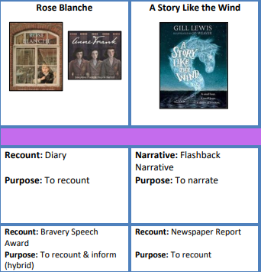 |  | 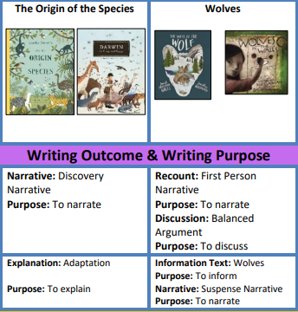 |  | 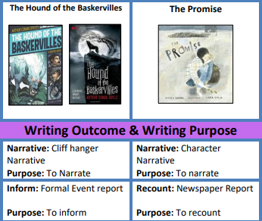
History | How can we take care to heal communities after times of war? |  | Were the poor treated fairly during the Victorian period?  The Industrial Revolution and The Workhouse |  | Can we learn about fairness by examining the lives of The Ancient Greeks?
Geography | Our Local Area |  | South America |  | Investigating Rivers
Science | Seeing Light  Changing Circuits |  | Evolution and Inheritance |  | Classifying Organisms  Healthy Bodies
DT | Burgers |  | Bird House Builders |  | Building Bridges
Art | Landscape Art |  | Frida Khalo |  | Sculpting Vases
Music | You’ve Got a Friend  Make You Feel My Love |  | A New Year Carol  Dancing in the Street |  | Panto Pandemonium  Music and Me
PE | Dodgeball  Yoga  Fitness |  | Gymnastics  Dance  Swimming |  | Athletics  Golf
PSHE | Being Me in My World  Celebrating Difference |  | Dreams  Goals and Healthy Me |  | Relationships  Changing Me
RE | UC God  What does it mean if God is holy and loving?  *Trip to church | Why is Muhammad important to Muslims?  (Islam) | UC Creation & Fall  Creation and science: conflicting or complimentary? | UC Salvation (Y6)  What difference does the resurrection make for Christians? | What Happens When We Die?  (Multi-faith, World View) | UC Incarnation  Was Jesus the Messiah?
ICT | Coding, Online safety, Spreadsheets |  | Databases, Game creator, 3D modelling |  | Concept maps
French | Phonics lesson 1-2 The Weather  Family |  | Pets  Olympics |  | At School  At the Weekend

 | Class 4 – Year B
 | Discovering the past and exploring the world, to create a better future
 | Autumn |  | Spring |  | Summer
Maths | Place Value, Four Operations, Fractions |  | Fractions, Decimals, Percentages, Ratio, Units of Measure, |  | Area, perimeter and volume, Algebra, Shape, Statistics
English Text | 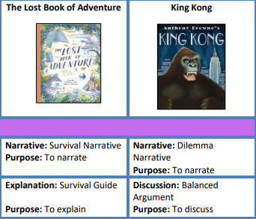 |  | 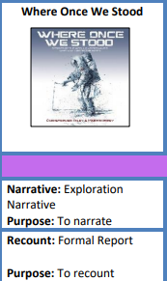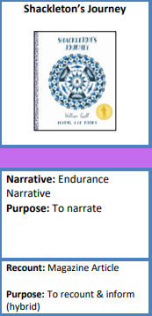 |  | 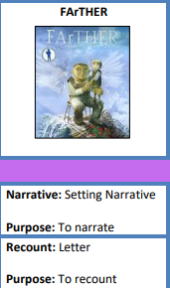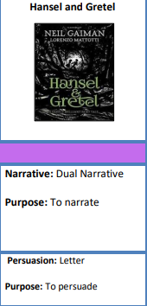
History | Vikings v Anglo Saxons |  | Can we respect the environment whilst exploring?  Space and deep sea exploration |  | What legacies have the ancient civilisations left behind?  Can uncovering the past be done respectfully?  Shang Dynasty of Ancient China
Geography | United Kingdom |  | North America |  | Extreme Earth
Science | Life Cycles |  | Earth and Space  Forces in Action |  | Changes and Reproduction  Properties and Changes of Materials
DT | Fashion and Textiles |  | Programming Pioneers |  | Chinese Inventors
Art | Express Yourself |  | Street Art |  | Chinese Art
Music | Living on a Prayer  Classroom Jazz 1 and 2 |  | The Fresh Prince of Bel Air  Happy |  | Tuishi Pamoja  Reflect, Rewind and Replay
PE | Handball  Orienteering |  | Football  Swimming |  | Rounders  Cricket
PSHE | Being Me in My World  Celebrating Difference |  | Dreams  Goals and Healthy Me |  | Relationships  Changing Me
RE | UC People of God  How can following God bring freedom and justice?  *Trip to church | UC Gospel  What would Jesus do? | Expressing Faith through the Arts  (Multi-faith, World View) | UC Salvation (Y5)  What did Jesus do to save human beings? | UC Kingdom of God  What kind of king is Jesus? | Sikh Worship and Community  (Sikhism)  *Visit to a Gurdwara
ICT | Coding, Online safety, spreadsheets |  | Blogging, text adventures, networks |  | Quizzing
French | Phonics lesson 3-4 The Date (I)  My Home |  | Clothes  Planets |  | Regular Verbs (P)/ Healthy living  Me and the World

