**Langar Church of England Primary School Early Years Foundation Stage Curriculum**



Our curriculum is a tapestry of these elements:

Characteristics of Effective Learning and the Role of the Adult

Features of Effective Practice

Planning and assessment

Continuous Provision and Enhanced Provision

|  |  |  |
| --- | --- | --- |
| Aims | Principles | Key actions to achieve these |
| To introduce our school core values of Take Care, Thoughtfulness, Fairness, Respect, Love, Gratitude.  To develop a child’s independence and sense of self, through a nurturing and valuing environment.  To develop a sense of team, modelled by the staff and valuing each pupil’s role in our setting.  To develop an awareness and understanding of ‘others’, appreciating the needs and beliefs of individuals.  To spark a ‘love of learning’ and fuel the children with knowledge and skills which will be built upon and flourish throughout their educational journey.  To ensure all pupils leave with a base of core knowledge and skills surrounding communication, language, literacy and mathematics. | Learning is exciting and is to be enjoyed by all.  All children should be inspired and supported to make educational risks, safe in the knowledge that they will always be valued.  Parent’s and carer’s contributions and voice are integral to the welfare and development of each pupil.  Children will have the opportunity to engage in a balance of child lead and adult lead activities and experiences through a range of high-quality provision.  Our high-quality interactions with the children are always valued as opportunities to push thinking, promote interpersonal skills and develop communication and language. | Our staff team embody early learning role models who share the children’s enthusiasm whilst using their extensive expertise to scaffold and learning and promote our core values.  Through a carefully constructed and progressive curriculum the children will develop skills and acquire knowledge to achieve the goals across all areas of learning.  Our curriculum is tailored to the knowledge and skills our children have in relation to our demographic and setting. We also strive to provide learning opportunities to help develop the children into well rounded, knowledgeable and valuing learners and members of the wider community.  Provision is of high quality and supports learning development opportunities in both indoor and outdoor settings.  Communication through our Tapestry App values both school and home learning. In addition to providing high quality support material to parents to further support home learning. |

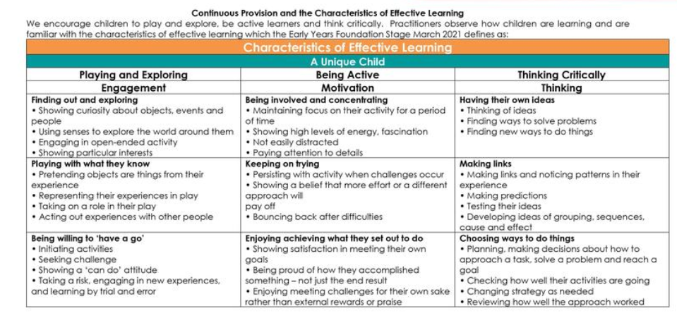

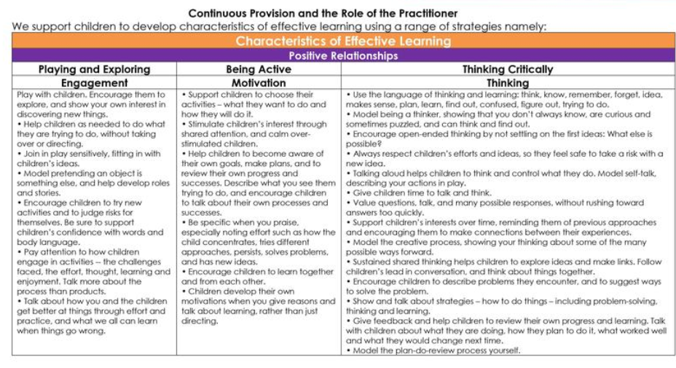

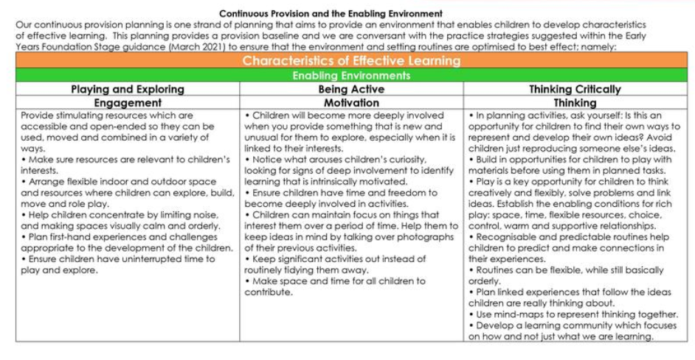

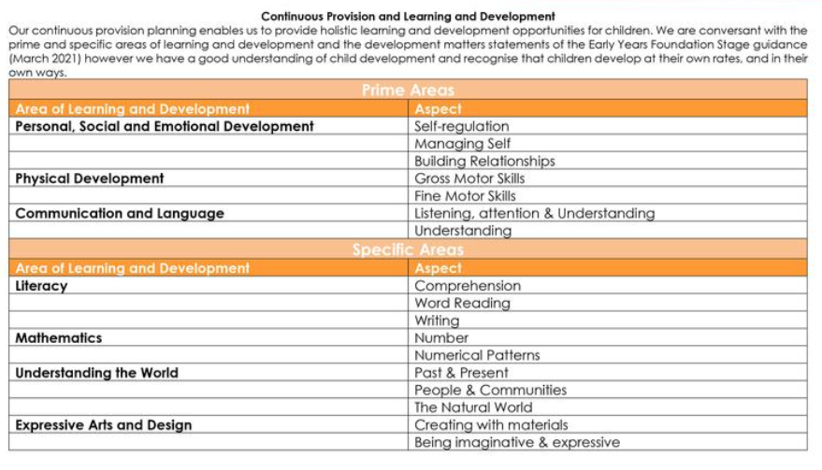

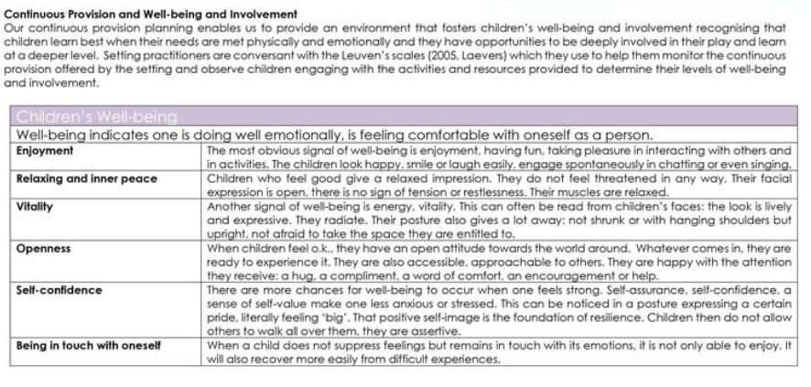

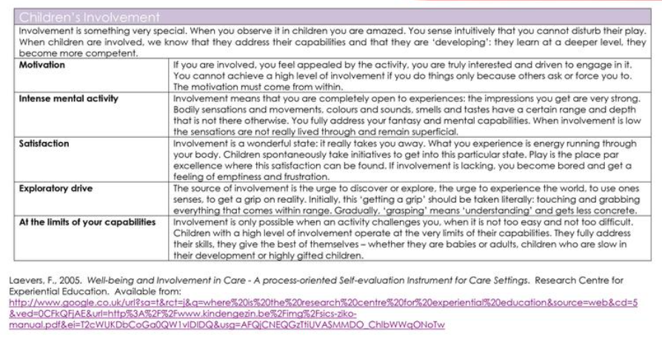

|  |  |  |
| --- | --- | --- |
| **Seven Features of Effective Practice** | **Key strands of the feature of Effective Practice** | **What we do at Langar Primary School to implement the feature of effective practice?** |
| The best for every child | Effective transition into  and out of our setting | Close links feeder Pre-School and nurseries –    Class Teacher has a phone call conversation with feeder settings key people to the child starting school to discuss and gain a wider understanding for each child.    SEND and Safeguarding concerns and support information are passed on to ensure appropriate provision, possible care plans and support can be put in place.    A ‘New Starter Meeting’ is conducted in the preceding Summer term for parents to meet the staff, ask questions and be informed of rules routines and expectations. ‘Getting ready for school’ packs and resources are handed out.    Transition into Foundation 2 begins in the Autumn term, mapped out as follows:    **WEEK 1 –** the class is split in half to create two groups. 1 group attends for two half days staying for lunch, the other group does the same for two half days, and on the fifth day the children join together for a half day staying for lunch.  **WEEK 2 -** children start full time.    This transition period allows for staff to focus on developing detailed knowledge of the individual children, and identification of arising need for support with time to implement provisions. Additionally, this time supports the development of relationships and routines in the new setting.    Foundation 2 share a playground with the rest of the school for dinner playtimes and lunchtimes, during which children become familiar with midday day staff.  Foundation 2 children will have a transition experience with the class 2 staff in the class 2 environment.  Foundation 2 staff have a hand over meeting with year 1 staff to pass on information and gain a wider understanding for each child.  Children with specific needs/support may have additional transition experiences with class 2 e.g. sharing of ‘all about me’ sheets, location of ‘safe spaces’ etc. |
| Expectations and aims | The development of skills towards the Early Learning Goals have been mapped out in each of the 17 areas to support the expected progression is made.  Any individual support and care plans are in place for the most vulnerable and these act upon the advice of specialist services. |

|  |  |  |
| --- | --- | --- |
|  |  | Children’s progress is tracked and gaps in learning are identified. Gaps are then planned to be closed through appropriate intervention.  Our setting aims to provide a learning environment and the desired provisions that meets the needs of all. |
| High quality care | Consistency of approach and expectations by all adults | staff pride themselves on the consistency of modelled behaviour and delivery of expectations.  Modelling and rewarding calm and caring interactions making specific links to our values of taking care and showing respect being two of our core values. Clear boundaries and routines following school’s behaviour and rewards systems and procedures.    Our marble jar is linked to our 6 values we uphold, and this is what our behaviour policy focusses on too.  All children’s names are displayed on marble jar on the wall at the start the day showing good behaviour as all children are expected to uphold these values. If a child displays undesirable behaviour and are not upholding the values a warning is given. If this continues for a second time, the child remove their name from the marble jar and sit in a quiet place with an adult to reflect on their behaviour. After a quiet moment the adult then enters into a reflective conversation with the child. The child then puts their name back on the marble jar    We follow the whole-school positive behavior policy which recognises and celebrates our core values Take Care, Thoughtfulness, Love, Fairness, Respect and Gratitude (see school behavior policy).    Promotion and support of independence and self-care via slowly developing routines, expectations and provision/curriculum activities. These developing expectations are shared through newsletters sent home. Food and drink provision supports a healthy lifestyle and is modelled by staff. |
|  | Safeguarding and welfare arrangements and procedures | All classes have a file where concerns and incidents are recorded, and all relevant staff are alerted.  *See Safeguarding Policy*  Child protection arrangements in place, known and applied by all.    Rigorous and proactive safeguarding work and procedures for matters such as medication and personal care. Safe and secure environment with all health and safety and ratio requirements met. Detailed risk assessments are carried out.  Adult to child ratios are abided by 1:30 onsite, 1:6 offsite. |

|  |  |  |
| --- | --- | --- |
|  |  | Children are involved in half termly online safety sessions.    Safer recruitment, conduct and induction processes applied for all adults including ensuring staff are suitably qualified and trained (including first aid).    Behaviour expectations and agreed systems for reward and sanction are known and applied by all adults. |
| The curriculum, what we want  children to learn |  | *See EYFS Curriculum Match (Red Document)*    The above document provides links to documents including clarity over the detail of the knowledge we want pupils to learn and the skills they develop. These progressive documents have considered appropriate sequencing to the development of knowledge and skills so that it is cumulative and progressive to ensure it meets end of EYFS expectation and feeds into the learning across the school.    Our curriculum design reflects key principles of science of learning such as: the need to revisit and retrieve/recall both knowledge and skills numerous times over a long period, the need to ensure cognitive load is not overwhelmed to prevent learning and the development of memory, a focus on explicit instruction of knowledge and skills before moving onto application, and proactively planning to ensure links and relationships across the curriculum are identified and made explicit to support the development of schema. Also, clarity and detail of how the knowledge and skills are reliant on each other and developed in unison have been considered.    The EYFS curriculum highly focuses and values the development of language and vocabulary. These skills and knowledge are carefully considered with clear and explicit planning for key vocabulary. Opportunities to encourage their implementation are both modelled and promoted by adults in free play and explicitly planned for during directed learning.    Our curriculum content and focus reflects the distinctiveness of the school’s context and that of the children. |
| Pedagogy: helping children to learn | Teaching and learning approaches | We aim to deploy and implement the most appropriate pedagogical approaches dependent on the intended learning and area of development. We use a range of pedagogical approaches which include learning through play, learning by adults modelling, learning by observing each other, learning through guided support and learning via some direct instructional teaching. As the year progresses so does the pedagogically shift towards a higher weighting of adult lead experiences in order to prepare the children for year 1.    Our indoor setting consists of one main classroom with windows and a door which looks out onto the outdoor area. Our outdoor setting consists of a fenced area with a door that leads from the classroom straight to the outside therefore allowing free flow to happen. We take great care to ensure our areas, both inside and out, are used and provide high-quality and purposeful provision. We ensure the continuous provision on offer in our setting are engaging, challenging and develop skills across the curriculum during child-initiated learning. Children engage in both guided and independent adult-initiated activities which are closely linked to our current engaging topics. |

|  |  |  |
| --- | --- | --- |
|  |  | Our continuous provision consists of a combination of continuous and enhanced provision. Continuous provision remains unchanged in the setting and allows for repeated experiences that can develop with the child and act as a safe and familiar resource to explore new learning. Enhanced provision is new and linked to topic or curriculum learning and allows for the exploration and investigation of new learning. |
|  | Role of adult | *See detail within the* ***characteristics of learning****.* |
|  | Enabling Environments (see turquoise columns of Characteristics of Effective  Learning documents) | Physical environment and timetabling enables each of the identified teaching and learning approaches to be implemented and delivered by adults.    The environment (both inside and outside) is physically organised and presented to promote high quality play, independent access to resources and activities, opportunities for large and small group teaching/activities, and 1-1 interactions.    This environment provides pupils with scaffolds, inspiration and support for the development, learning and application of new knowledge and skills. It is an environment in which pupils feel safe, secure and confident. They have a sense of place and ownership and it both celebrates their successes and inspires them to try new things and independently apply previous learning.    Indoor learning areas, as previously mentioned, are comprised of continuous and enhanced provision. Prime areas of C&L and PS&ED are naturally fostered through the social nature of interacting with peers in the classroom and are modelled and supported by adults. Our selfcare station provides children with the opportunity to take ownership of their own basic hygiene including nose blowing and hand washing using sanitiser. They can also access their fruit and milk and water bottles here too. Fine motor skills are supported on our funky fingers table. Specific areas are supported through our reading corner, phonics table, maths corner, writing area, homecorner which includes malleable and loose parts, creative table painting table, curiosity cube, construction area which includes small world, investigation baskets, and an occasional games / puzzle table    Outdoor learning areas reflect indoor learning environments and act to provide pupils with scaffolds, inspiration and support for the development, learning and application of new knowledge and skills. Prime areas of C&L and PS&ED are also naturally fostered through the social nature of interacting with peers in the outdoor area and are modelled and supported by adults. Fine motor skills are supported through a range of core outdoor provision including the writing |

|  |  |  |
| --- | --- | --- |
|  |  | shed, investigation tweezers, den pegs and beanbags. Gross motor skills are supported through a range of core outdoor provision including large construction, balancing beams, stepping stones and steps. Specific areas are supported through our Literacy Shed, Maths Shed, Sand Kitchen, water and sand play. |
| Assessment: checking what children have learnt | Clarity over why we assess | Staff understanding of the Early Learning Goals and preceding developmental steps enables all adults to support learning and identify when children have reached benchmarks and expectations.  Staff understanding of what assessments will shape future learning experiences and inform the interventions and provisions which follow. |
| Clarity, expertise and consistency of how we assess | Training and moderation through the LA  Termly meetings with Reception staff from our Fosse Schools.  Guidance and supporting documentation such as half termly benchmarks used to support judgements  Agreed understanding over how we record and store information from assessments from SLT  Discussions related to borderline assessment decisions and sharing of assessment knowledge related to groups and individuals  Clarity over assessment being an ongoing process as part of the wide range of teaching and learning interactions with children not just one off focussed tasks or activities (assessment to be part of teaching and learning not taking adults away from this) |
| Making effective use of the information we gather by responding effectively and precisely | Ensure school’s planning cycle uses assessment findings (our own, previous setting and parents) to identify what **all** children already know and what they can do. This to then informs planning to make sure teaching and learning activities build upon what children can already do (and are interested in) and provide opportunity to teach, and for children to develop, the next steps in all areas of learning and development.    Use the range of assessment findings to consider if they are highlighting that a child may have a special educational need and there needs to be a planned response in partnership with others such as school SENCO and specialist agencies.    All staff clear on the learning intentions our enabling environments and specific activities are designed to help pupils attain and develop.  When working with pupils on focussed activities and playing alongside them we make continuous small assessments that help us identify knowledge and understanding. This ‘in the moment’ assessment is then used to respond in precise and individualised ways to aid pupils in learning new things, refining their actions and consolidating their existing knowledge and understanding.    Arising gaps in children’s learning which have been identified inform the selection for, and aims of, targeted intervention groups. Information regarding the children’s intervention progress is monitored and informs future interventions and learning experiences.    Gaps of learning identified in phonic assessments informs the selection of one of the home reading books to help practice selected sounds. |
|  | Clarity over how we make, record and track formal summative assessment judgements | (DfE Baseline is conducted during the first 6 weeks of starting school. This information coupled with school specific baseline gathering will inform a baseline judgement for on track or off track.    School specific half termly judgements are made through knowledge of the child, evidence gathered and through discussions with adults in the setting. These judgements inform next half term’s targets. These judgements also inform half termly interventions.    Phonics assessments made at the end of each phase. |
| Self-regulation and executive function | Self regulation | *See detail within the* ***characteristics of learning*** *documents.*  *Language development is central to self regulation, children use their language to guide their actions and plans.*  *We* use the Jigsaw scheme for PSHE |
| Executive function | ***“listening and attention”, “self regulation” and “managing self”*** |
| Partnership with parents | Communication and sharing of information and valuing the knowledge parents have and the contribution they make | Transition: parent information meeting to introduce staff and parents and share key transitional information, expectations and aims. Parents also have the opportunity to have discussions with staff. Parents are provided with the teacher email should they wish to email over any questions, queries or information. Parents receive a welcome booklet and essential information. Parents fill in an ‘All About Me’ sheet with essential information they wish to pass on about their child and during the summer holidays are asked to create an ‘All About Me Box’ with their child to share in class.    Ongoing throughout EYFS: weekly sharing of learning intentions and what has been taking place, class webpage, parents meetings, newsletters uploaded to the class webpage, day to day verbal communication and sharing of information, information passes through home reading diary, specialist parent meetings such as ‘what is phonics and how we teach it?’, parents evenings and posts through our online evidence portal ‘Tapestry’. |
|  | Providing support and guidance to parents | Transition: parent information meeting, welcome booklet and sharing of school readiness leaflet, class email providing individualised support if necessary.    Ongoing throughout EYFS: weekly sharing of learning intentions and what has been taking place, home learning activities, specialist parent meetings such as ‘what is phonics and how we teach it’, day to day verbal communication and sharing of information and advice on how to support their child, information passed through home reading diary.    Meetings with parents to respond to individual needs and circumstances (including in partnership with other such as SENCO and outside agencies). |

How our EYFS provision and curriculum are organised and integrated/matched to school’s Yr1-Yr6 curriculum to enable them to be the foundations of the KS1&2 curriculum

|  |  |
| --- | --- |
| EYFS Strand/Area | National Curriculum Subject(s) this is a key foundation for |
| Listening,  Attention and  Understanding | English: Speaking & Listening |
| Speaking | English: Speaking & Listening English: Grammar |
| Self Regulation | PSHE/RSE |
| Managing Self | PSHE/RSE |
| Building  Relationships | PSHE/RSE |
| Gross Motor Skills | PE |
| Fine Motor Skills | English: Writing  Art  DT |
| Word Reading | English: Reading |
| Comprehension | English: Reading |
| Writing | English: Writing |
| Number | Maths |
| Numerical Patterns | Maths |
| Past and Present | History |
| People, Culture and Communities | Geography  RE  PSHE/RSE |
| The Natural  World | Science  Geography |
| Creating with materials | Art  DT |
| Being Imaginative and Expressive | Art  Music  PE |
|  | Computing *(not an ELG or explicit area of EYFS but school has an EYFS computing programme they use called Purple Mash. Additionally, it is expected that pupils will be introduced to, and learn to use, appropriate technology through provision that meets other elements of EYFS)* Shape *(not an ELG but a key element of EYFS maths curriculum)* |