**Outdoor Learning Challenge – Wednesday, 29th April 2020**

Fancy an outdoor activity this afternoon?

Why not have a go at building a Bug Hotel for the insects in your garden?

Using a few spare bricks, tiles and slabs. You can create a great little house for many of the creatures who inhabit your garden.

Pack it with layers of sticks, twigs, hay or stones to create places for the bugs to crawl into and hide.

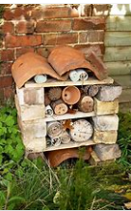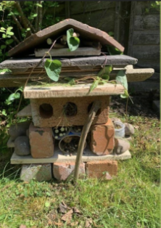

Please send into the school office pictures of yours!

Mrs George

