**Outdoor Learning Challenge – Wednesday, 3rd June 2020**

**Its Den Building Day!!!!**

**It’s a perfect day to make a Den either inside or outside. You have all had a go at building them at school so remember what worked and what didn’t.**

**If you are brave enough why don’t you see if its water proof – outdoor dens only!**

**Things you might need – ask permission first?**

* 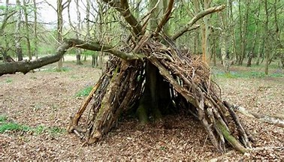**Blankets/sheets**
* **Pegs**
* **Rope for making a structure**
* **Cushions for inside when done**
* **Chairs/tables**

**Remember to always tidy up after yourself. Please don’t drop litter, especially if you use manmade materials.**

**Look after living trees and plants: they take years to**

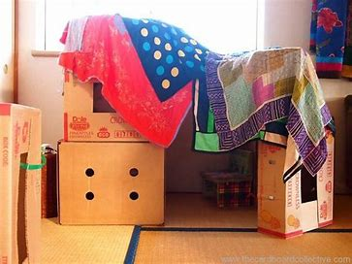**grow and seconds to destroy.**

**Enjoy – Mrs George**