**Outdoor Learning Challenge – Wednesday, 6th May 2020**

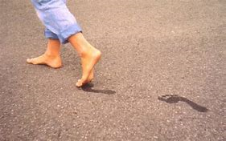**Put your hands up if you have given up wearing shoes/slippers I know I have – so let’s go outside this afternoon with no shoes on into the garden and really feel what is under your whole foot!!**

**Firstly, lets mark out a short route – maybe even put some obstacles in place but make sure you can hold somebody’s hand to get you through if you need to.**

**Think about different textures such as grass, mud, water and tarmac try and get as many different ones as possible.**

**As you walk your route think about your descriptive vocabulary of how it actually feels under your feet and in between your toes!! What is really important is how it makes you actually feel!**

**Being connected to the ground can be a wonderful connection to our inner self and wellbeing.**

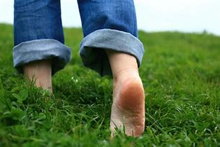**Go for it!!!!**