Homework set4.11.24
To be completed 10.10.24
Homework will be set on a Monday and is expected to be completed by the following Monday.
A spelling check will take place on a Monday.
TTRS challenges will also finish on a Thursday evening or Friday morning. The minutes for the following week will restart on a Friday.
The children are encouraged to carry out an independent learning project throughout the half term related to our topics. The science focus this half term is ‘Living in Environments ‘’. Our History focus is ‘Why did the Anglo Saxons come to Britain?’ We always enjoy sharing the children’s projects and welcome their creativity.

Please support your children to choose something they are interested in and help make it an exciting, investigative experience to promote a love of learning through the arts.

The children will get a chance to share their projects with the class. If you would like to use half term to complete the projects, we would love to see them on your return.
Reading | Children are expected to read to an adult at least 3 times a week and this should be recorded in their reading diary. The children are being encouraged to record in their reading diaries themselves too. We are creating a love of reading within class and the focus is on enjoyment and sharing their preferences with others through book reviews. The children are thinking carefully about what they have read each day and recording any interesting use of vocabulary, literary devices and analysing the author’s choices. Please encourage these conversations at home too.
TTRS | There will be a weekly / fortnightly challenge set on TTRS for the children to take part in. All children are expected to play on Garage for at least 15mins. The challenge will always end on a Thursday evening ready for certificates to be handed out during our celebration assembly.
Numbots | Children are encouraged to complete 15 minutes on numbots per week. This will help with their fluency / number sense and addition and subtraction facts.
Lexia | All children have a Lexia account are expected to complete a 20 minute session a week at home. This intervention is aimed to support your child with their spelling and reading skills.
Rollama | The Year 4 children have a Rollama account where they can access activities for Grammar practise. I will set a challenge to support the grammar learning we are doing in class. Year 3s -watch this space for your logins……
IF YOUR CHILD IS STRUGGLING WITH ANY OF THE ABOVE ACTIVITIES PLEASE ASK THEM TO SPEAK TO MRS NICHOLSON, MR HALL or MRS GEORGE. WE WILL BE HAPPY TO HELP AND SUPPORT YOU WHERE WE CAN.
 | YEAR 3 Words with aigh and eigh  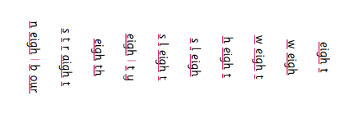  - Paperweight  - neighbourhood | YEAR 4 Words with /i / spelled y  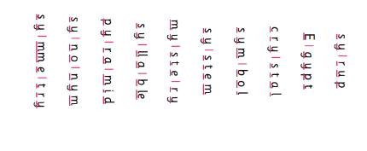  *apocalypse  *synchronise
And spellings | The following words are from our statutory year 3 / 4 spelling list. We will be focusing on these words for the next week.  Forward  Possible  Increase  Length  Breath  Though  Purpose  Mention  Pressure  Height  Try and solve the wordly spelling challenges.  Last weeks wordly puzzles to master. New wordless have arrived.  https://wordly.org?challenge=Zm9yd2FyZA  https://wordly.org?challenge=aW5jcmVhc2U  https://wordly.org?challenge=bGVuZ3Ro  https://wordly.org?challenge=YnJlYXRo  https://wordly.org?challenge=dGhvdWdo  https://wordly.org?challenge=cHVycG9zZQ  https://wordly.org?challenge=aW5jcmVhc2U  https://wordly.org?challenge=cHJlc3N1cmU  https://wordly.org?challenge=bWVudGlvbg  https://wordly.org?challenge=cG90YXRvZXM  https://wordly.org?challenge=Y2VudHVyeQ  https://wordly.org?challenge=cmVpZ24  https://wordly.org?challenge=c3BlY2lhbA  https://wordly.org?challenge=cGVjdWxpYXI  https://wordly.org?challenge=YWN0dWFsbHk  https://wordly.org?challenge=cGVyaGFwcw  https://wordly.org?challenge=cG9wdWxhcg  https://wordly.org?challenge=d2VpZ2h0  https://wordly.org?challenge=ZGlmZmljdWx0
Your child will bring home a sheet to help them practise their spellings. Please support them to complete the challenges. Some children will bring extra sheets home to help them practise.

