Coming Back To School

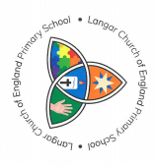

Soon some children will be coming back to school. When you come back to school things will be a bit different.

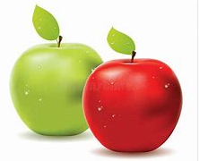

You may not be with all of your class. You will be with the children from your year group, your own teacher and a teaching assistant – this will be your bubble.

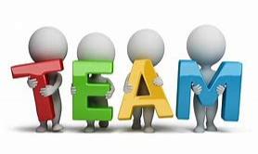

This team will be together each day that you are in school.

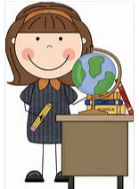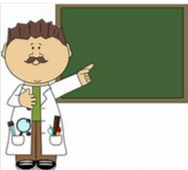

Your bubble will be based in your own classroom, or the hall if you are coming in because your parent is a keyworker.

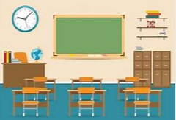

The classrooms will look a bit different – the tables will be spaced out, there won’t be lots of cushions or soft toys around. There will still be books, some toys and equipment for learning.

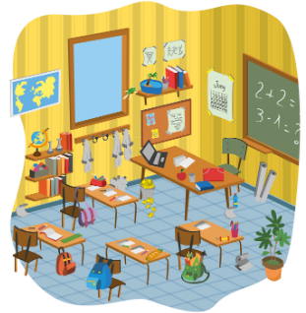

You will have your own pack that includes a pencil, pen, whiteboard and rubber and some toys and things like that – you won’t have to share!

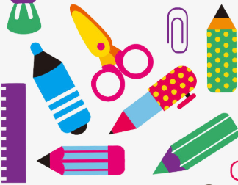

Everybody will be having their lunches at lunch times as usual.

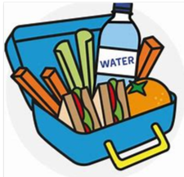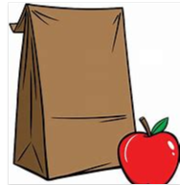

You will eat this in your team’s room.

You will still get to go outside for lots of exercise and every team has their own area to work and play in. This may be at different times than you are used to.

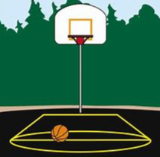 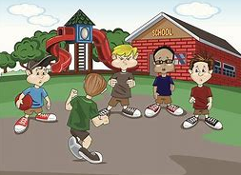

You will not need to wear uniform, but will need to wear clean clothes every day. It will be a good idea to wear trainers as we plan on going outside and being active as much as possible.

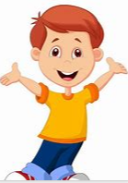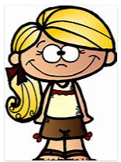

Because there is a virus around we will be washing our hands a lot more to help keep everyone safe and each bubble will have their own set of toilets.

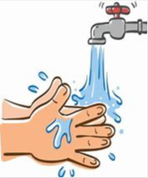

It will be lovely to be back in school and see our friends again, but we must remember to try to keep a little bit away from each other. We can still be friends even if we don’t touch.

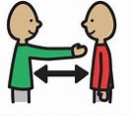

Your teachers and all the adults in school are really looking forward to seeing you and we can all help each other keep safe whilst we are learning.

