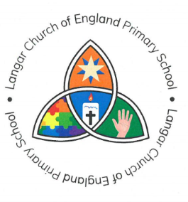

**Langar C of E Primary School**

Head Teacher:

Barnstone Road Mrs E J Brown

Langar

Nottingham

NG13 9HH

01949 860056

12 September 2023

Dear Parents

I will be holding a meeting after lunch next Tuesday for all children that would like to start the recorder. The lessons will take place on a Tuesday afternoon on a rota basis. The children will be expected to practice at least 3 times a week, in order to progress. Please ensure that they understand this before they start the lessons. Your help with this would be appreciated, as it is difficult to move forward without encouragement from home.

The children will need a recorder and the music book, ‘Recorder from the beginning’ by John Pitt, Book 1. This is available on the internet.

Learning the recorder is a great benefit to children if they wish to progress onto other instruments. It is great fun and is a very rewarding step into the world of music.

Best wishes

Sarah Whelan

Music coordinator