

Langar C of E Primary School

Dear Parents/Carers,

The purpose of reporting to parents is to create a partnership, to aid and expand your child’s learning experience. With your support and guidance at home, children make more rapid progress and secure a positive attitude towards learning, ensuring education is not seen as a school based job but that learning is for life.

Learning is a journey. In school we review children’s progress on this journey by undertaking regular assessments and observations; celebrating the achievements and planning opportunities to heal gaps and mop up misconceptions. The sooner these interventions take place, the smoother the learning journey is. With our team of highly skilled teachers and TAs these interventions usually take place either during the lesson or through carefully designed support programmes. We would like to make you an active part of this journey.

We report to you on a termly basis to provide an insight into your child’s current position on their journey across the year. Reporting will be published on the same form each term that will track children towards their end of year targets. You will receive the latest snapshot report on ***Monday 27th March***. Teachers will be using a blended approach to generate a child’s position on this grid, utilising both formal assessments (test papers) as well as informal teacher assessments (observations and work done daily). Your child’s end of year target is marked on the grid. This was a target set based on their starting points (either on entry to EYFS or KS1 assessment).

In order for your child to be making good progress they should be moving nearer to their end of year target, bearing in mind we are two thirds into the year. If you keep each report, you can track their journey, this is an example of how a year 4 child moved across the grids last year.

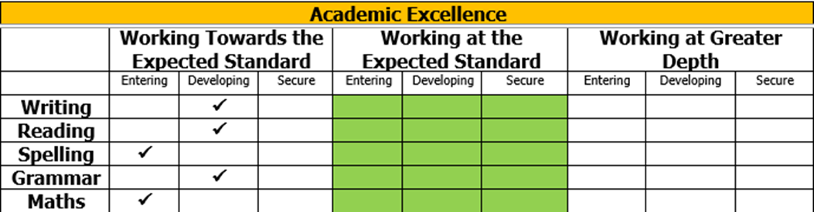

Autumn

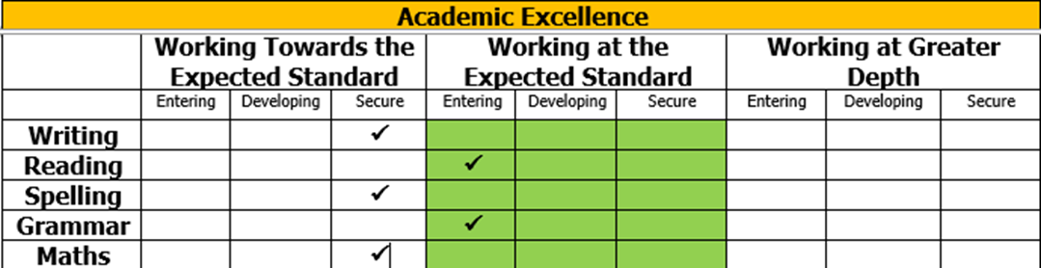

Spring

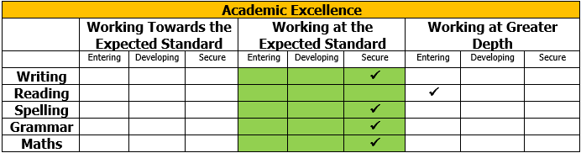

Summer

If you are concerned about the progress they are making, then you will be given the opportunity to talk to your child’s teacher to find out the areas of learning you need to support them in.

Following the receipt of the snapshot report you will have a parent/ teacher meeting. This will provide an opportunity for your child’s teacher to discuss academic strengths and gaps in their learning, what you can do to help them, the way in which they uphold the school values and utilise learning skills.

These meetings will take place via Zoom and will be held ***across this week.*** A Zoom link will be sent out in an email at the start of that week – click the link to join the meeting.Join the meeting five minutes before your allocated time slot where you will be held in the waiting room.Ensure ***the name displayed is your child’s name*** (names the teacher does not recognise will not be let into the meeting).If two parents wish to access the meeting but will not be using the same device, please let us know on your slip so that you can both be let into the meeting.Meetings will be a prompt ten minutes long and will be ended by the teacher even if they are not finished. Should you have a matter that needs discussing that you know will take longer than ten minutes, please arrange your meeting for another time.

Following the virtual meeting you will be invited to a Connect and Reflect afternoon where you can come in and celebrate your child’s learning with them and get a flavour of the work they are doing in school. This will take place in the afternoon of Friday 21st April .

We do hope you find this way of reporting to you useful and meaningful, and look forward to continuing to work in partnership with you for the good of your children.

Yours sincerely,



Mrs. E. J. Brown