

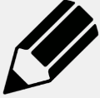

* Copy the words from the list into your spelling book



* Say the words in your **normal voice** **and** your **spelling voice**

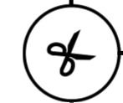

* Snip the word into syllables using bars

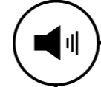

* Say and write the sounds for each syllable

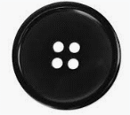

* Draw the sound button for each sound in each syllable – dot for one letter, dash for more than one

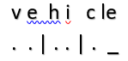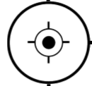

* Highlight the ‘tricky’ sounds

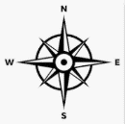

* Write just the dots, dashes, and syllable bars next to the word to create the **word map**



* Can you find any other ways of mapping the word?