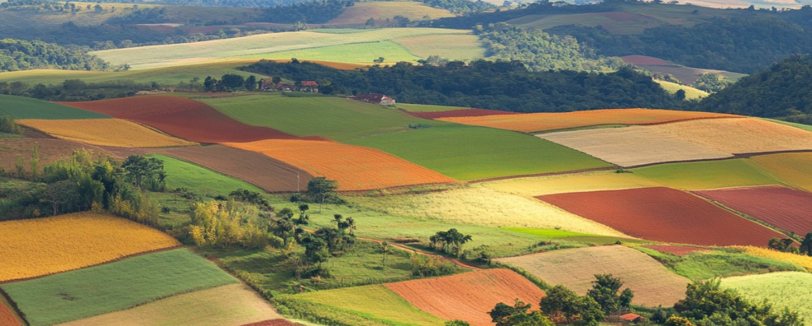
The Big Idea…
‘The one who plants and the one who waters work together with the same purpose. And both will be rewarded for their own hard work. – 1 Corinthians 3:8. In this half term we set out on a quest to understand what is happening in the fields all around us. We will learn about food production here at Langar and how it has shaped the landscape around us. We’ll learn about the journey from field to fork and talk to the farmers who make it all possible. Once we’ve done our research, we’ll present our work to the wider community on our Flourishing Farms exhibition day! 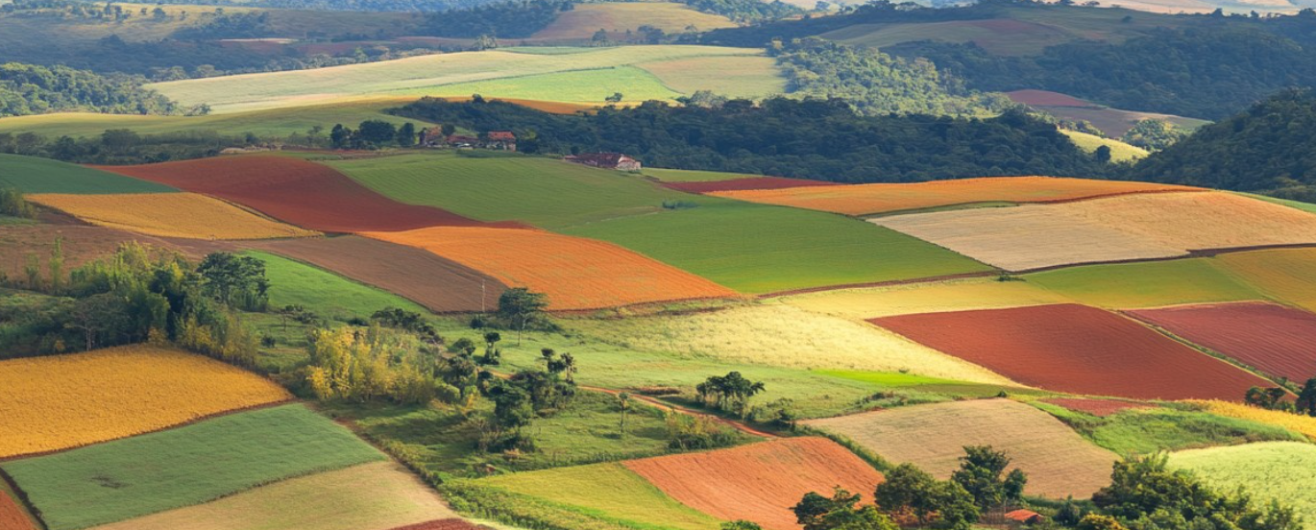

As mathematicians we will
In maths we will be working on place value. We will look at number bonds to 10 and 20 and use these to help with addition and subtraction. We will look at properties of shapes and think about the shapes we can see in the world of farming.
As language specialists
Class 2 will start the term using Drawing Club. We will have fun looking at a variety of farm inspired stories including Farmer Duck, The Little Red Hen, Pumpkin Soup and The Enormous Turnip. We will create our own farm inspired stories too. We will create simple fact files about all things farming. We will continue with Phonics in Year 1 and Year 2 will follow Essential Spelling, which is the natural progression from our Year 1 Phonics work.

As geographers we will…
Look at the different types of farms that are around Langar and how these help the wider community. We will enjoy creating and playing with farms as part of our provision activities.

As historians we will…
Look at how farming equipment has changed over time and make comparisons.

As scientists we will…
Find out what plants need to grow well- how do our crops grow and what are they used for. We will also see how one ingredient can become different foods! We can link our knowledge of foods with keeping healthy.
We will be identifying the animals that are found on a farm and the food that they can provide for us.
‘
Across the curriculum

As musicians - All across school we’ll be learning about how the Bible is filled with references to harvests, shepherds, cattle and fishes. We’ll prepare for our harvest festival by learning a range of classic and new ways to celebrate the plentiful world that God gave us. Class 2 will learn songs linked to farming – Tractor Ted might be helping us to do this!
As expressive artists –We will look at the work of Yayoi Kusama who created amazing art based on circles but will also use her work about pumpkins to create our own fruit and vegetable inspired art. We will also use our memories of Flintham Show to paint tractors and other farming equipment. We will also create our own farm vehicles as part of our provision activities.
As computer specialists we will learn how to keep ourselves safe online.
As fitness experts – We will look at why running is an important part of any game and skill and practice jumping hopping and skipping. We can link this to how a variety of farm animals move. We will look at the importance of eating healthily too.

Spirituality
God provided us with a land of plenty. The bible teaches us to look after the world and treat it as a special gift from God. It also teaches us the value of hard work. We will learn how Jesus uses farming to teach us about life.
Values
What does it mean to share the fruits of the harvest fairly? In a world where there is plentiful food, why do people still go hungry? How to we show gratitude to those who provide us with food? How do we respect our planet – a glorious gift?
Exhibition
We will display our work at our Flourishing Farms exhibition. You might be able to try some food too!
Flourishing Farms

