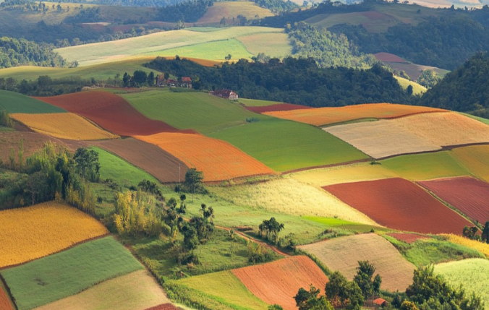
As Literacy specialists
We will:
-enjoy our Drawing Club sessions and immerse ourselves in a range of books about animals which will include fairystories, tales and animations.
-enjoy books such as Farmer Duck, The Pig in The Pond, Rosie’s Walk, The Little Red Hen, What the Ladybird Heard and recall what has been read to us.
-use our early mark making skills and draw pictures relating to the books we read, and create our own thoughts and ideas.
-begin to identify and match letters to sounds as part of our daily phonics programme and write initial sounds on small and large scales.
-orally segment and blend words, and segment and blend for writing
As mathematicians
We will:
- be using our White Rose Scheme and objects and animals to match and sort to a variety of criteria. We will use mathematical vocabulary linked to size to order objects by size and compare size.
- practise counting and matching numerals to quantity.
To develop our understanding of the world…
We will:
-find out about jobs on the farm and what a farmer does.
- find out about the different times of the year which are important for farmers, such as harvest time or when it is time to sow seeds.
-explore seeds and life cycles
Look at how tractors are used and how horses were used in the past.
-understand the effect of changing seasons
- have opportunities to explore planting and growing their own seeds.
-observe, handle and describe fruits and vegetables.
-find out about different crops.
-enjoy our whole school trip to Flintham Show!
As expressive artists and designers
We will:
-explore materials and texture and artistic techniques.
-develop pencil skills to draw pictures of animals
-print and explore shapes and patterns.
-learn about collage to create farm animals.
-select colours to paint pictures of animals, farms and tractors

The Big Idea:
This term, we are going to explore the wonderful world of farms! We will be learning all about what happens on a farm and the important jobs that farmers do every day.
Here is what we will be discovering:
- What Farmers Grow: We will find out what crops farmers plant in their fields, like wheat, corn, and vegetables. We willl learn how these plants grow and what they need to stay healthy.
- Harvest Time: We will explore how farmers collect their crops when they are ready, and what tools they use to help them. We will even talk about how the food gets from the farm to our plates!
- Tractors and Machines: We will look at the big machines farmers use, especially tractors! We will learn what they do and how they help farmers with their work.
- Farm Animals: we will learn about the animals that live on the farm, like cows, pigs, sheep, and chickens. We will learn how farmers take care of them and what these animals give us, like milk, eggs, and wool.
There will be lots of fun activities, stories, and chances to explore and play as we learn all about life on the farm!
When we have finished our learning, we will have a whole school Flourishing Farms exhibition day!

In our physical development…
We will:
-be learning how to manage our own self-care within independence using the toilet and showing good basic hygiene skills.
-show some dexterity when holding a pencil and writing our letters taught in phonics.
-begin to make simple marks and shapes using simple equipment.
-develop the control and increase accuracy using tools such as scissors, playdough tools, digging tools.
-use large scale construction to make farms and tractors.
-have PE

To develop personal and social skills…
We will:
-build positive relationships with our new friends in the class and teachers through play and activities.
-get used to routines, school values and develop in confidence in whole school sessions such as collective worship, dinnertime and playtime.
-talk about our own life experiences.
-talk about the feelings of others.
-show respect for the environment and understand that we all need things to grow and to be healthy.
To develop Communication and Language skills…
We will:
-be talking about Farms and learning rhymes with actions everyday.
-learn lots of new vocabulary - animals on the farm, crops grown, names of vehicles, seasons - use these words in play.
-share lots of stories and encourage children to join in and re-tell parts.
-enjoy small world play and role play provisions to provide opportunites to use story language and enhance vocabulary.
-use talk to describe, explain and a way of building relationships with others.
Flourishing Farms
Reception
Autumn Term 2025

